1. 标题：德国信用卡数据
2. 实例数：本项目使用文件german.data，其提供了20个属性（13个类别属性+7个数字属性）共1000个实例，最后一列表示类别（分别为1和2）
3. 属性说明

|  |  |  |  |
| --- | --- | --- | --- |
| 分类 | 属性名称 | 取值范围 | 列名(重命名) |
| 基本信息数据 | 属性 13:(数字)年龄 |  | age |
|  | 属性7:(定性)当前就业状态 | A71：失业 A72 : ... < 1 年 A73 : 1 <= ... < 4 年 A74 : 4 <= ... < 7 年 A75 : .. >= 7 年 | person_employee |
|  | 属性 17:(定性)工作状态 | A171：失业/非技术人员 - 非居民 A172：非熟练 - 居民 A173：熟练员工/官员 A174：管理/个体经营/高素质的员工/官员 | job |
|  | 属性9:(定性)婚姻状态和性别 | A91：男：离婚/分居 A92：女：离婚/分居/已婚 A93：男：单 A94：男：已婚/丧偶A95：女：单 | marry_sex |
|  | 属性 11:(数字)现居住地 |  | address |
|  | 属性15:(定性)房产状态 | A151 : 租房 A152 : 自己的 A153：免租房 | housing |
|  | 属性 18:(数字)赡养人数 |  | dependents |
|  | 属性 19:(定性)电话注册情况 | A191：无 A192 : 是的，以客户名义注册 | have_phone |
|  | 属性20:(定性)是否有国外经历 | A201：是的 A202：没有 | foreign_worker |
| 信用数据 | 属性1:(定性的)现有支票账户的状态 | A11 : ... < 0 A12：0 <= ... < 200 A13 : ... >= 200 A14 : 没有支票账户 | account_status |
|  | 属性 2:(数字)期数或借款持续月份 |  | period |
|  | 属性3:(定性)历史信用记录 | A30 : 没有记录/所有贷款已按时偿还 A31 : 这家银行的所有贷款都已按时偿还 A32 : 存在未到期的信贷 A33 : 过去延迟还清 A34：现有的重要账户/其他信用（不在这家银行） | history_credit |
|  | 属性4:(定性)借款目的 | A40：汽车（新） A41：汽车（二手） A42：家具/设备 A43：广播/电视 A44：家用电器 A45：修理 A46：教育 A47：（假期） A48：再培训 A49：商业 A410 : 其他 | credit_purpose |
|  | 属性 5:(数字)额度 |  | credit_limit |
|  | 属性 6:(定性的)储蓄账户状态 | A61 : ... < 100 A62：100 <= ... < 500 A63：500 <= ... < 1000 A64 : .. >= 1000 A65：未知/没有储蓄账户 | saving_account |
|  | 属性10:(定性)其他担保人 | A101：无 A102 : 共同申请人 A103 : 担保人 | other_debtor |
|  | 属性12:(定性)财产状况 | A121：房地产 A122：建房协会储蓄协议/人寿保险 A123：汽车或其他 A124：未知/无属性 | property |
|  | 属性 16:(数字)这家银行的现有信用卡数量 |  | credits_num |
| 消费数据 | 属性 8:(数字)分期付款率占可支配收入的百分比 |  | income_installment_rate |
|  | 属性 14:(定性)其他分期情况 | A141 : 银行 A142 : 商店 A143：无 | installment_plans |
| 行为数据 |  |  |  |
|  |  |  |  |
| 标签 |  | 真实逾期情况 1：good， 2：bad | target |

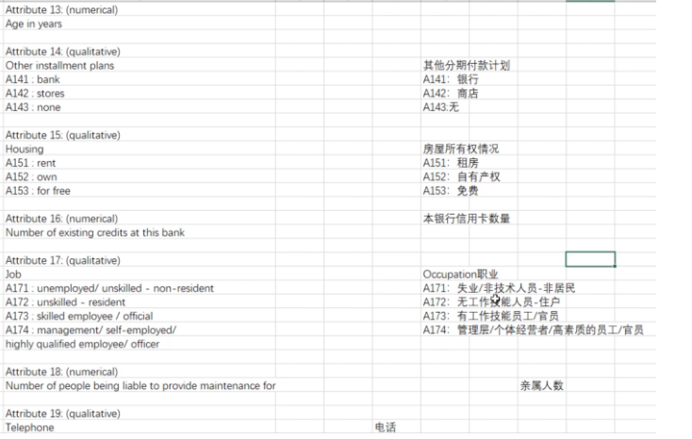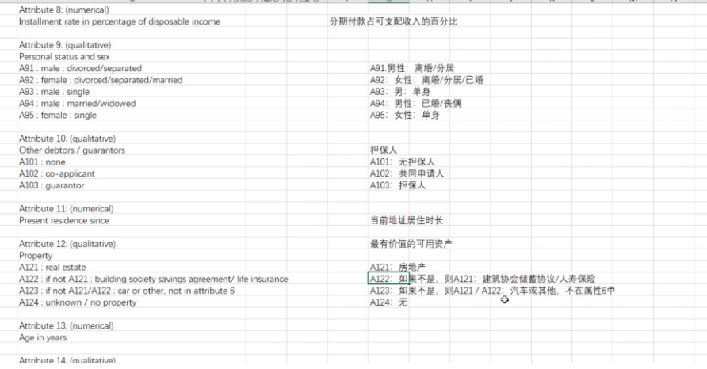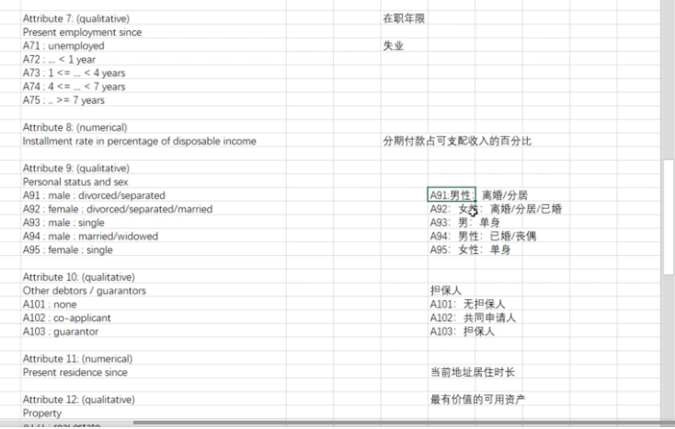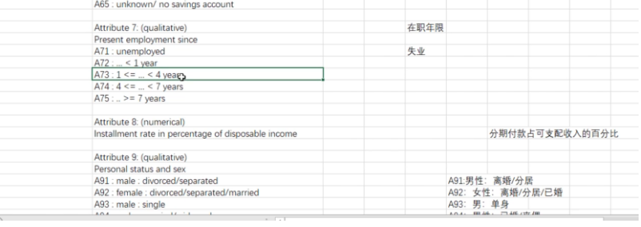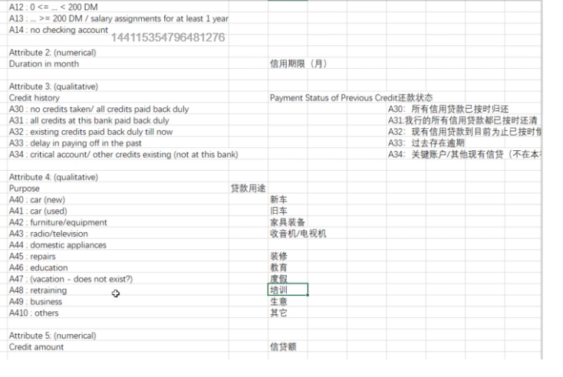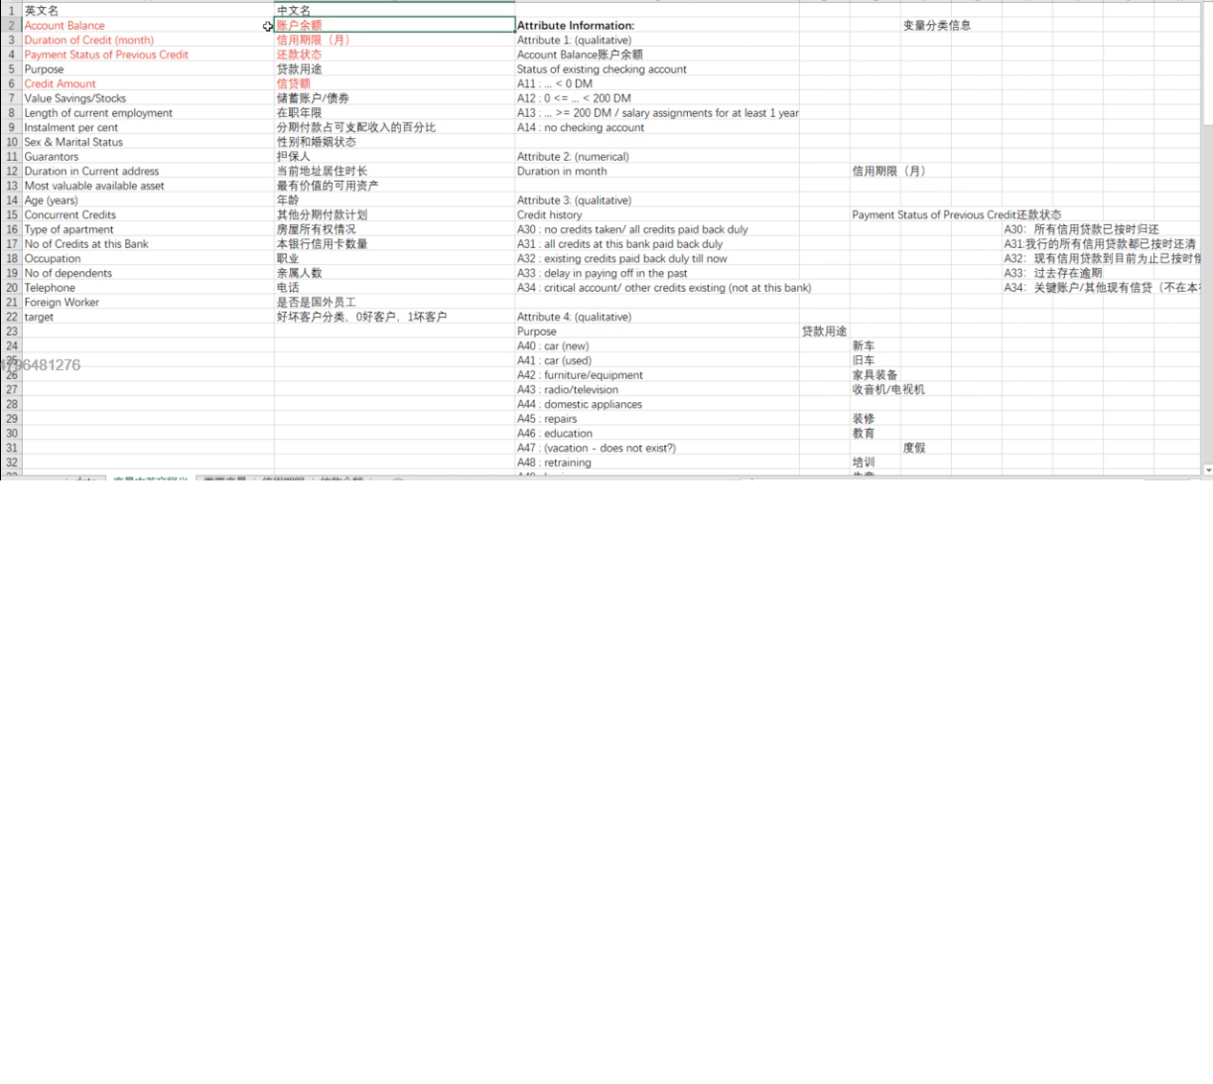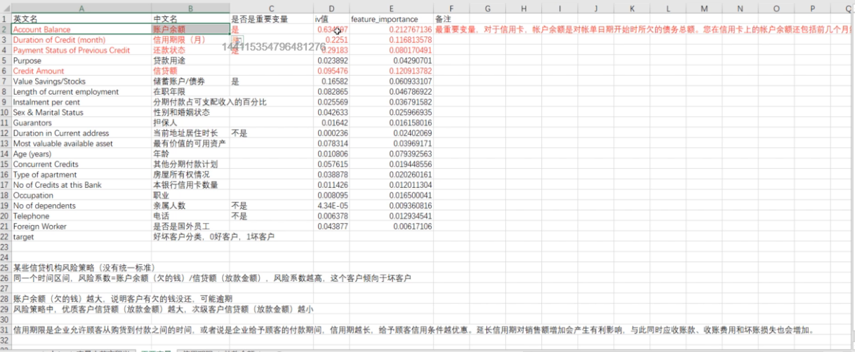

英文说明

Description of the German credit dataset.

1. Title: German Credit data

2. Source Information

Professor Dr. Hans Hofmann

Institut f"ur Statistik und "Okonometrie

Universit"at Hamburg

FB Wirtschaftswissenschaften

Von-Melle-Park 5

2000 Hamburg 13

3. Number of Instances: 1000

Two datasets are provided. the original dataset, in the form provided

by Prof. Hofmann, contains categorical/symbolic attributes and

is in the file "german.data".

For algorithms that need numerical attributes, Strathclyde University

produced the file "german.data-numeric". This file has been edited

and several indicator variables added to make it suitable for

algorithms which cannot cope with categorical variables. Several

attributes that are ordered categorical (such as attribute 17) have

been coded as integer. This was the form used by StatLog.

6. Number of Attributes german: 20 (7 numerical, 13 categorical)

Number of Attributes german.numer: 24 (24 numerical)

7. Attribute description for german

Attribute 1: (qualitative)

Status of existing checking account

A11 : ... < 0 DM

A12 : 0 <= ... < 200 DM

A13 : ... >= 200 DM /

salary assignments for at least 1 year

A14 : no checking account

Attribute 2: (numerical)

Duration in month

Attribute 3: (qualitative)

Credit history

A30 : no credits taken/

all credits paid back duly

A31 : all credits at this bank paid back duly

A32 : existing credits paid back duly till now

A33 : delay in paying off in the past

A34 : critical account/

other credits existing (not at this bank)

Attribute 4: (qualitative)

Purpose

A40 : car (new)

A41 : car (used)

A42 : furniture/equipment

A43 : radio/television

A44 : domestic appliances

A45 : repairs

A46 : education

A47 : (vacation - does not exist?)

A48 : retraining

A49 : business

A410 : others

Attribute 5: (numerical)

Credit amount

Attibute 6: (qualitative)

Savings account/bonds

A61 : ... < 100 DM

A62 : 100 <= ... < 500 DM

A63 : 500 <= ... < 1000 DM

A64 : .. >= 1000 DM

A65 : unknown/ no savings account

Attribute 7: (qualitative)

Present employment since

A71 : unemployed

A72 : ... < 1 year

A73 : 1 <= ... < 4 years

A74 : 4 <= ... < 7 years

A75 : .. >= 7 years

Attribute 8: (numerical)

Installment rate in percentage of disposable income

Attribute 9: (qualitative)

Personal status and sex

A91 : male : divorced/separated

A92 : female : divorced/separated/married

A93 : male : single

A94 : male : married/widowed

A95 : female : single

Attribute 10: (qualitative)

Other debtors / guarantors

A101 : none

A102 : co-applicant

A103 : guarantor

Attribute 11: (numerical)

Present residence since

Attribute 12: (qualitative)

Property

A121 : real estate

A122 : if not A121 : building society savings agreement/

life insurance

A123 : if not A121/A122 : car or other, not in attribute 6

A124 : unknown / no property

Attribute 13: (numerical)

Age in years

Attribute 14: (qualitative)

Other installment plans

A141 : bank

A142 : stores

A143 : none

Attribute 15: (qualitative)

Housing

A151 : rent

A152 : own

A153 : for free

Attribute 16: (numerical)

Number of existing credits at this bank

Attribute 17: (qualitative)

Job

A171 : unemployed/ unskilled - non-resident

A172 : unskilled - resident

A173 : skilled employee / official

A174 : management/ self-employed/

highly qualified employee/ officer

Attribute 18: (numerical)

Number of people being liable to provide maintenance for

Attribute 19: (qualitative)

Telephone

A191 : none

A192 : yes, registered under the customers name

Attribute 20: (qualitative)

foreign worker

A201 : yes

A202 : no

8. Cost Matrix

This dataset requires use of a cost matrix (see below)

1 2

----------------------------

1 0 1

-----------------------

2 5 0

(1 = Good, 2 = Bad)

the rows represent the actual classification and the columns

the predicted classification.

It is worse to class a customer as good when they are bad (5),

than it is to class a customer as bad when they are good (1).